Problem Management
WHY:
The fact that computerisation is now a pervasive element of most organisations infrastructure has lead to the requirement to fully optimise their use.

End users will face issues in their use of computer systems. In ITIL terms we refer to these as incidents. A “pattern” of incidents is a “problem”. Failure to halt the recurrence of incidents leads to lost time and frustrated users. Users who have to ask for the same issue to be fixed day after day will quite rightly lose their patience.

Effective problem management halts the recurrence of incidents and has benefits to the individual and the organisation as a whole.

GOAL: The goal of Problem Management is to minimise the adverse impact of Incidents and Problems on the business that are caused by errors within the IT Infrastructure, and to prevent recurrence of Incidents related to these errors.

ACTIVITIES:
Problem = Unknown underlying cause of incident (s)
Known Error = Known underlying cause of incident (s)

The major activities of Problem Management are:
- Problem control
- Error control
- The proactive prevention of Problems
- Identifying trends
- Obtaining management information from Problem Management data
- The completion of major Problem reviews.

Problem control:
Identifying the real underlying causes.
- Problem identification and recording (link to Incident Management)
- Problem classification - in terms of the impact on the business
- Problem investigation and diagnosis (link to all other ITIL processes)
- CLOSE problem before going into error control

Error control:
- Identify and register Known Errors
- Assess Known Errors and identify possible solutions (if necessary!)
- Raise RFC to remove Known Errors affecting the IT infrastructure to prevent any recurrence of Incidents (link to Change Management)
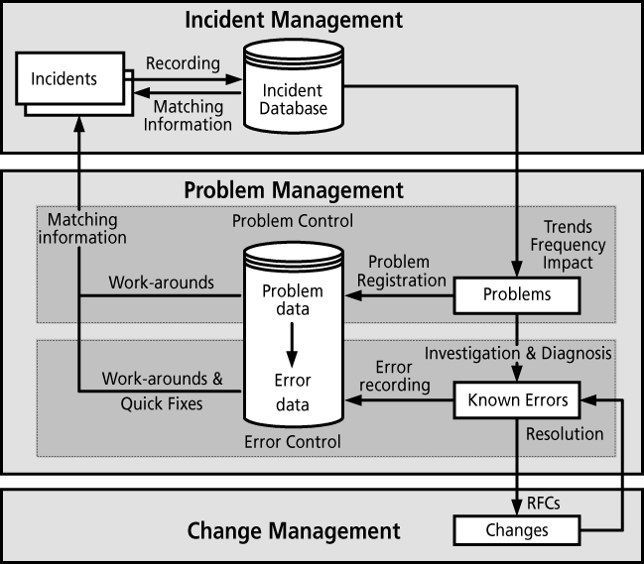

Proactive Problem Management
- Identifying and resolving Problems and Known Errors before Incidents occur.
- Trend analysis
- Targeting of preventive action.

Trend Analysis

Providing management information

Major Problem reviews
On completion of the resolution of every major Problem, Problem Management should complete a major Problem review.
- What was done right
- What was done wrong
- What could be done better next time
- How to prevent the Problem from happening again.

RESULTS:

Accurate Work Around Database

Accurate overview of Know Errors

Insight in Weak areas in the IT Infrastructure

More pro-active service Support

Bridging Incident Management and Change Management

Decrease in support cost because of better IT staff allocation

COST:
- Personnel – Support staff (Set-up and ongoing)
- Accommodation – Physical location (Set-up and ongoing)
- Software – Tools (Set-up and ongoing)
- Hardware – Infrastructure (Set-up)
- Education – Training (Set-up and ongoing)
- Procedures – external consultants etc (Set-up)

BENEFITS:

Improved IT service quality. Problem Management helps generate a cycle of rapidly increasing IT service quality. High-quality reliable service is good for the business users of IT, and good for the productivity and moral of the IT service providers.

Incident volume reduction. Problem Management is instrumental in reducing the number of Incidents that interrupt the conduct of business.

Permanent solutions. There will be a gradual reduction in the number of and impact of Problems and Known Errors (once fixed stays fixed)

Improved organisational learning. The Problem Management process is based on the concept of learning from past experience. The process provides the historical data to identify trends and the means of preventing failures and of reducing the impact of failures, resulting in improved User productivity.

Better first-time fix rate at the Service Desk. Problem Management enables a better first time fix rate of Incidents at the Service Desk, achieved via the capture, retention and availability of Incident resolution and Work-around data within a knowledge database available to the Service Desk.

